Lesson 3 Demo 3: Deploy a Registry

This section will guide you to:

* Deploy a registry

**Step 1**: Run a local registry

* Run the following command to start the registry container:

*sudo docker run -d -p 5000:5000 --restart=always --name registry registry:2*

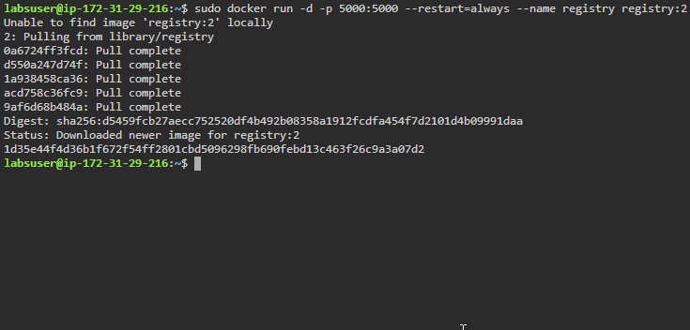

* List the running containers to check the newly created container

*sudo docker ps*

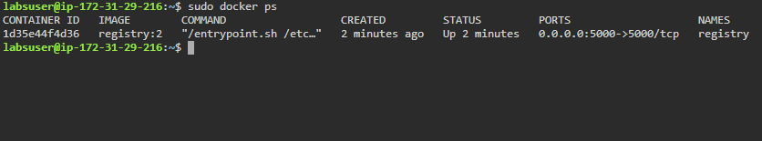

**Step 2**: Copy an image from Docker Hub to your registry

* Pull the Ubuntu image using the command:

*sudo docker pull ubuntu:16.04*

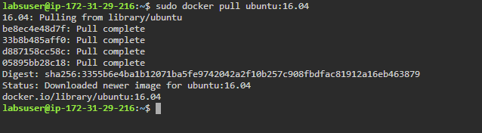

* Use the following commands to tag the *ubuntu* image and check the running images:

*sudo docker tag ubuntu:16.04 localhost:5000/my-ubuntu*

*sudo docker ps*

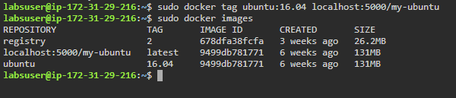

* Push the image to the local registry using the command:

*sudo docker push localhost:5000/my-ubuntu*

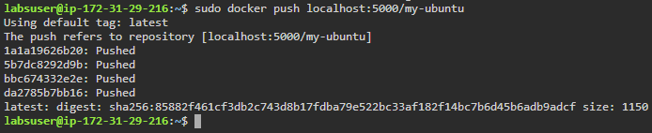

* Remove the locally cached images using the command:

*sudo docker image remove ubuntu:16.04*

*sudo docker image remove localhost:5000/my-ubuntu*

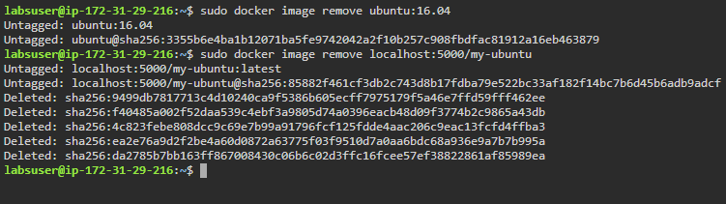

* Pull the *localhost:5000/my-ubuntu* image from the local registry

*sudo docker pull localhost:5000/my-ubuntu*

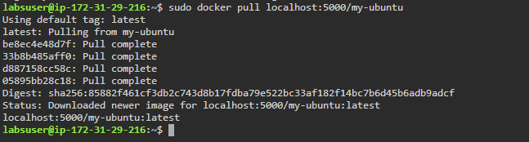

**Step 3**: Stop the running registry

* Use the following command to stop the running registry container:

*sudo docker container stop registry*

